One Day Workshop on Physics

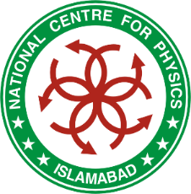
and Technology of Accelerators
(National Users Meeting)
23 November, 2015
Organized by
National Centre for Physics, Islamabad

Registration Form

Title: Dr. Mr. Ms.
Full Name: ____________________________________________________________________
CNIC #: ____________________________________________________________________
Address of Organization/University: ______________________________________________
________________________________________________________________________________
Contact No: Cell: ______________________ Landline (with area code) ______________________
E-mail: ______________________

Highest Academic Qualification: PhD MPhil MSc

Participation Status: Student
(Please Tick the appropriate)
Researcher

Faculty Member

Participation Category: Oral Presentation

Poster Presentation

Only Participation

Accommodation Required: Yes No

___________________
Signature of Applicant

Scanned copy of dually completed and signed registration form may also be submitted at caad@ncp.edu.pk or fax at +92 51 2077342 on or before November 10, 2015.

Postal Address: Manager CAAD
Collaboration & Academic Activities Department
National Centre for Physics, QAU Campus, Shahdara Valley Road, Islamabad
Tel.: 051-2077350, Fax.: 051-2077342, 051-2077395

